An Overview of the Candidate Base Icon Packs for FRC Distro

Papirus
Papirus is a soft and colorful raster icon theme that features thousands upon thousands of icons. Even one for Among Us! It is a very popular icon pack on many distros, and it is pretty much guaranteed to work flawlessly other than the raster icon problem; if an icon is scaled at a resolution that it was not exported for, it can become a bit fuzzy at times. Papirus works to avoid this rare occurrence by exporting many sizes of all the icons. A very good option.

Apps
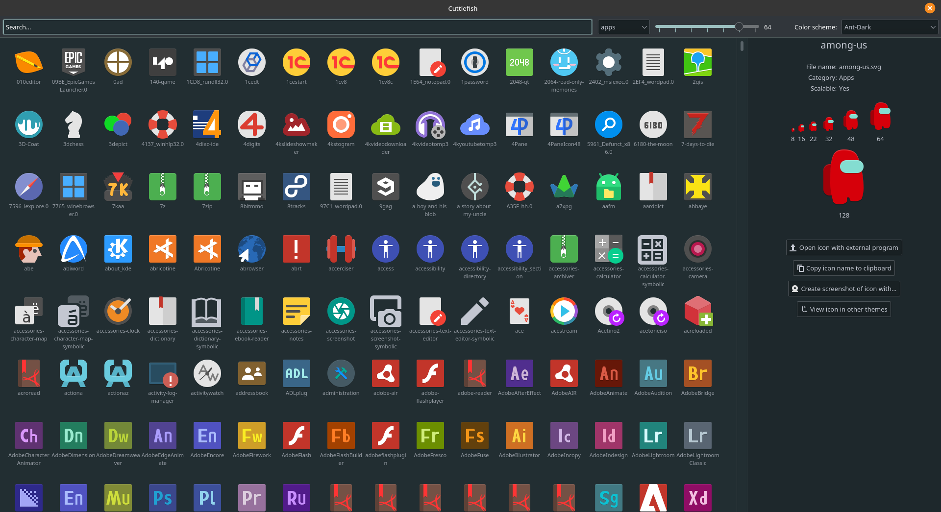

Mimetypes
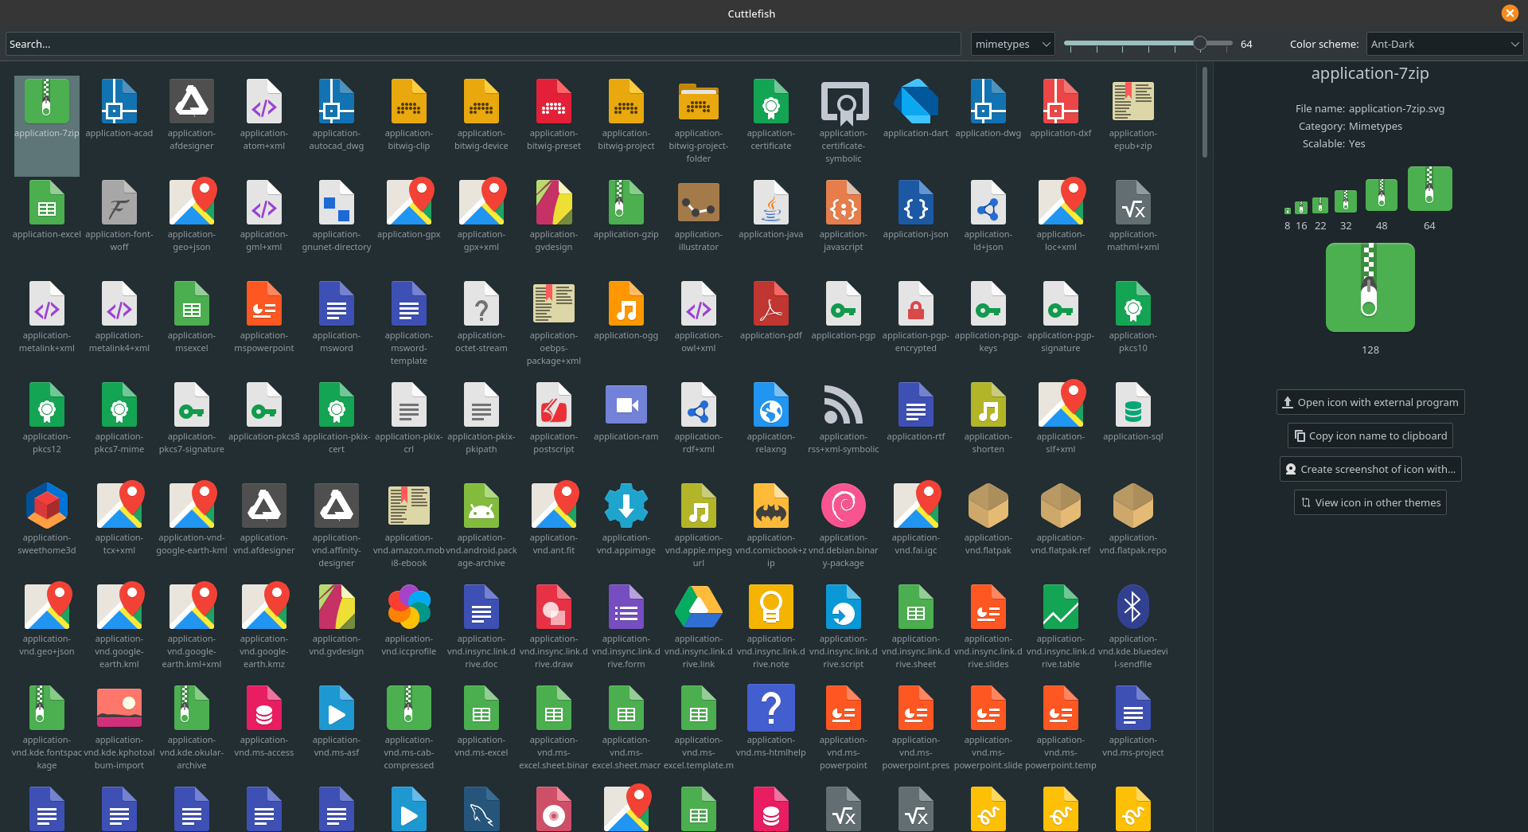

Places
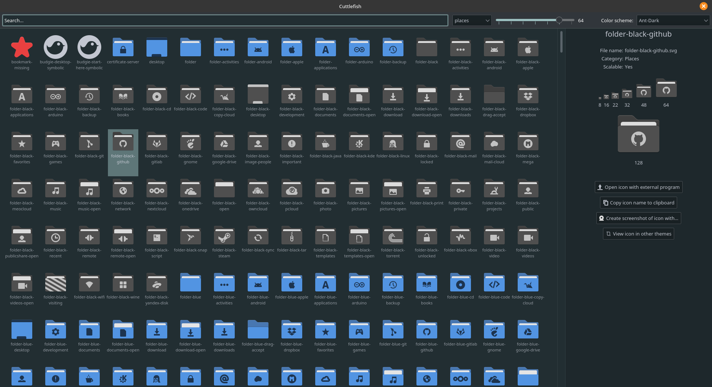

Folder Colors Support
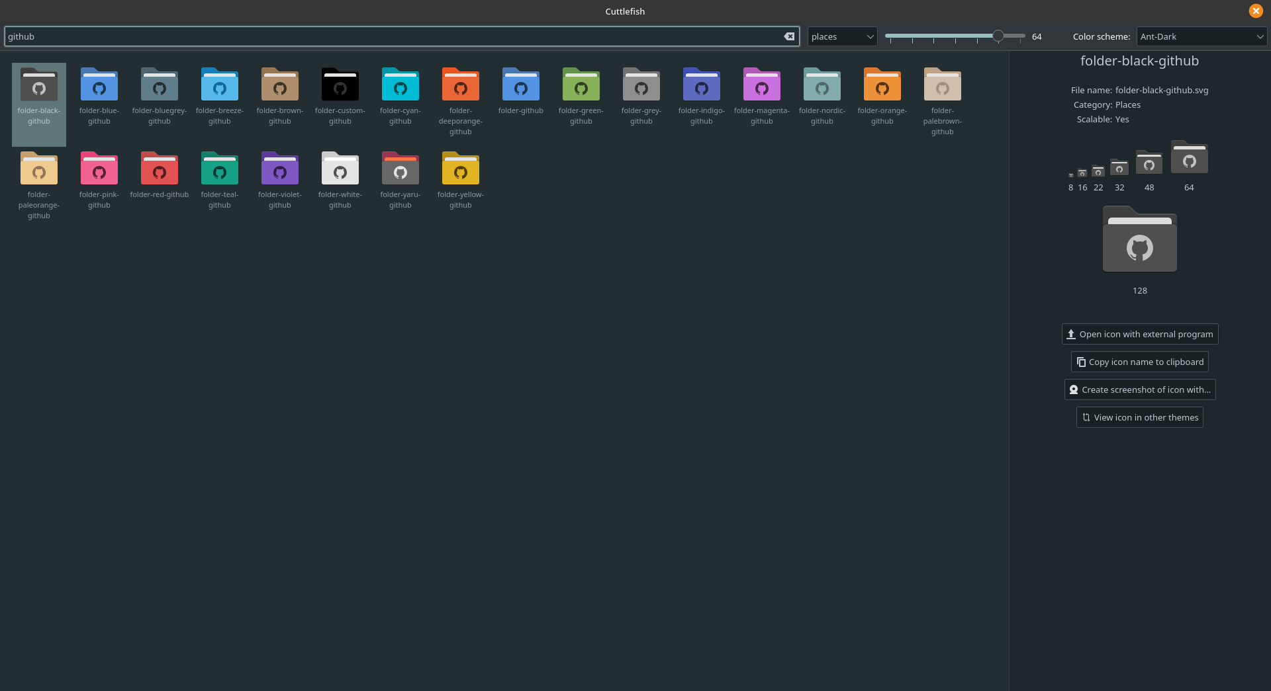

Breeze
Breeze is more of a classical, hard icon theme that is featured as default in KDE Plasma, so it would definitely feel fairly at home in the FRC distro. It does not feature many icons at all, but instead leaves app icons mostly up to the app developers and is thus compliant with the #stopthemingmyapps movement. The cost is that sometimes the app icons clash horribly. Overall, a good and stable option that feels to me like it could belong on the FRC homepage. It is also a vector theme, making it completely scalable, very flexible, and quite small in file size.

Apps
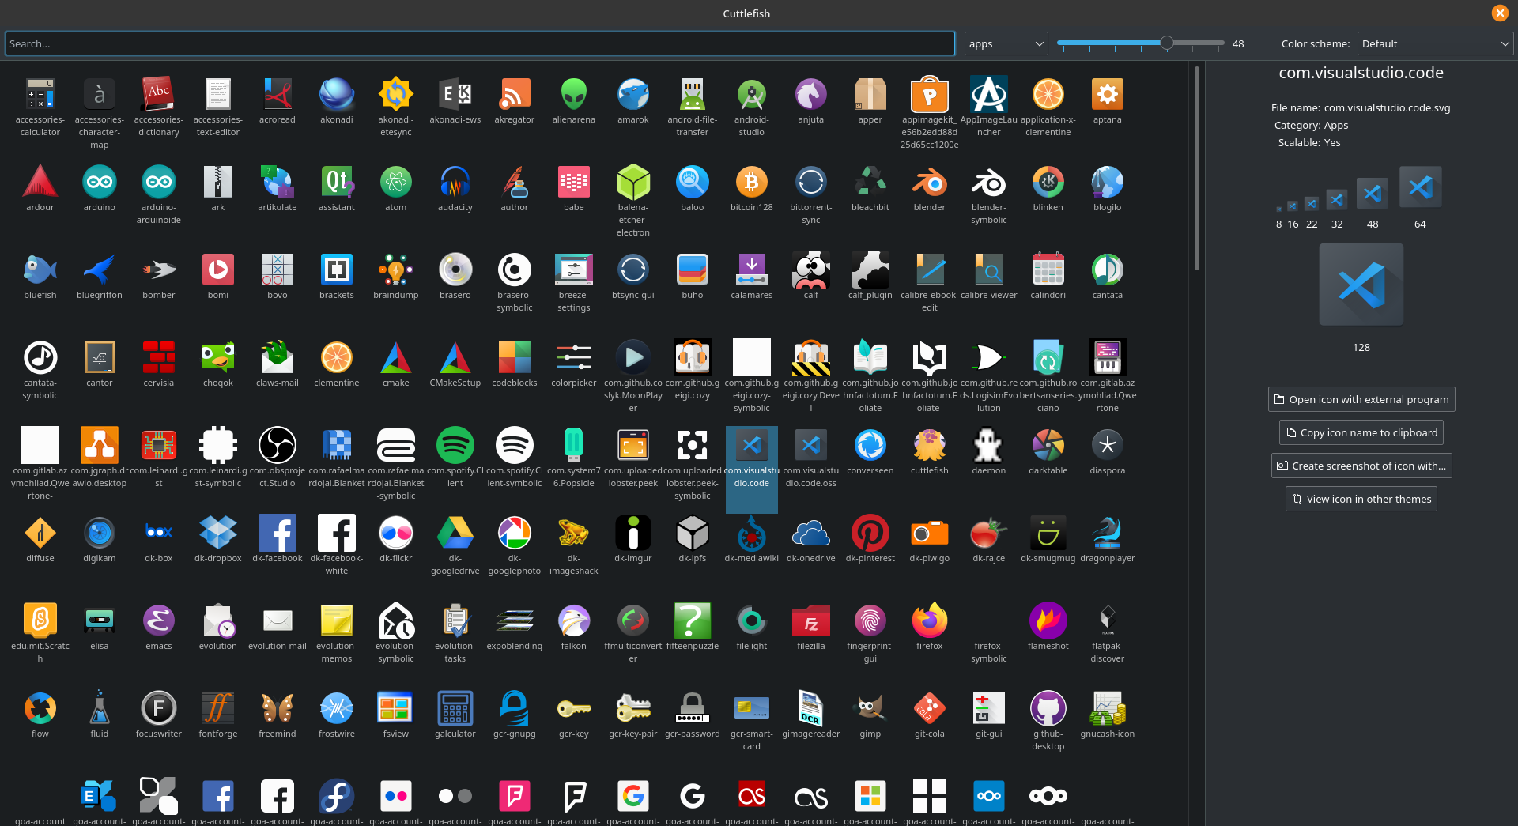

Mimetypes
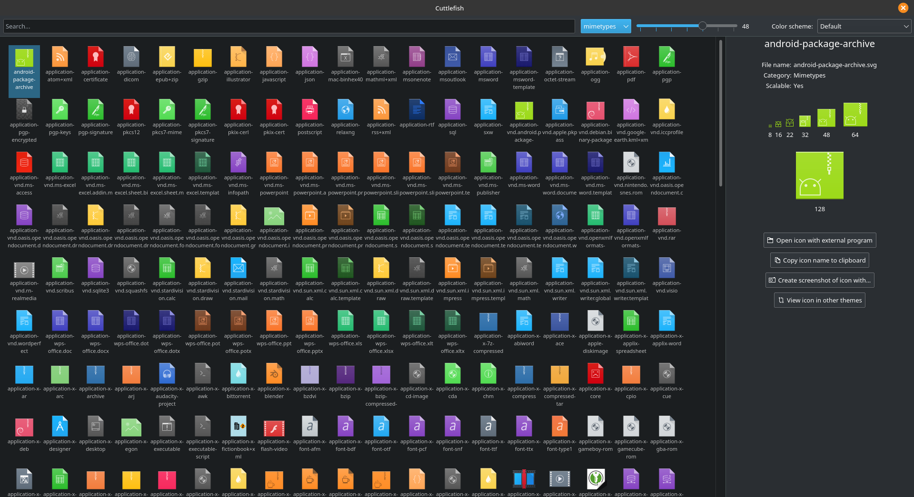

Places

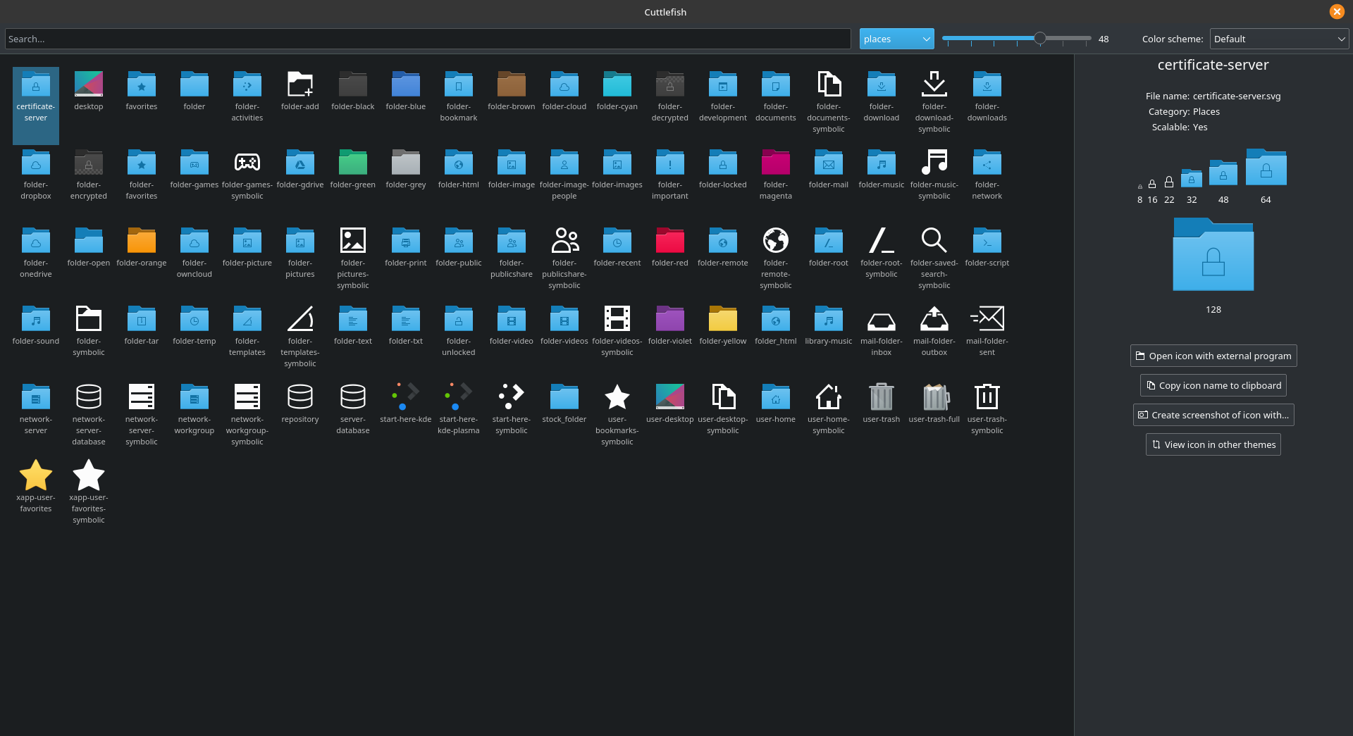
Folder Color Support
Breeze does not feature folder color support.

Tela
Tela is a happy, softer, material icon pack that is entirely vector format. Like Papirus, it is very colorful. It doesn’t feature nearly as many icons as Papirus (nothing does) but being a comprehensive pack, it covers the vast majority of apps. It is known for fitting perfectly with material themes and is very easy to create icons for. It is also alive and constantly adding more icons.

Apps
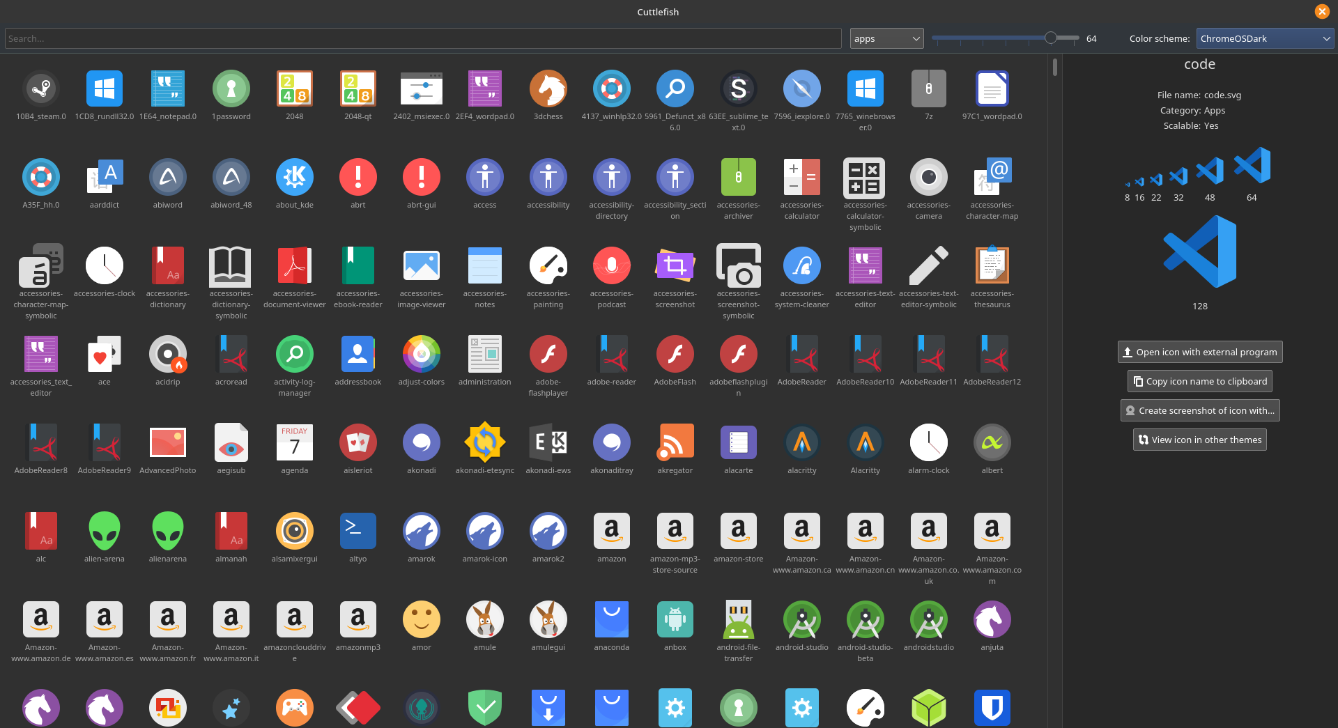

Mimetypes

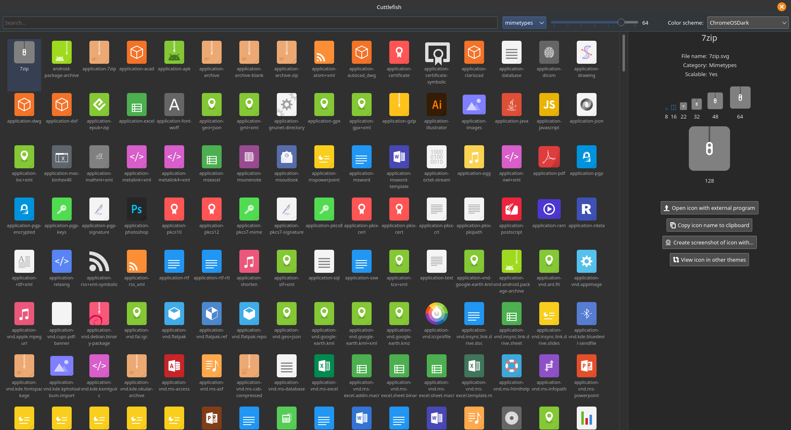Places
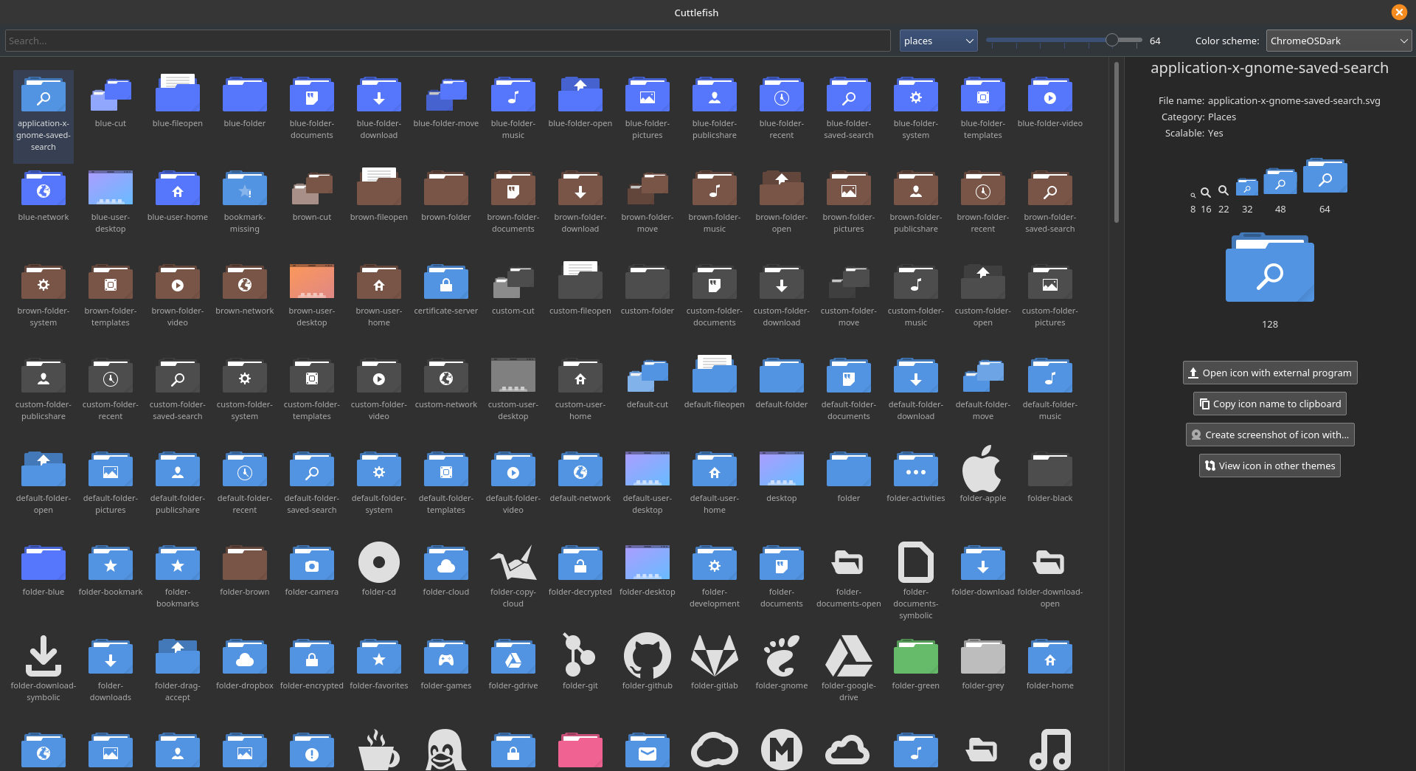

Folder Color Support

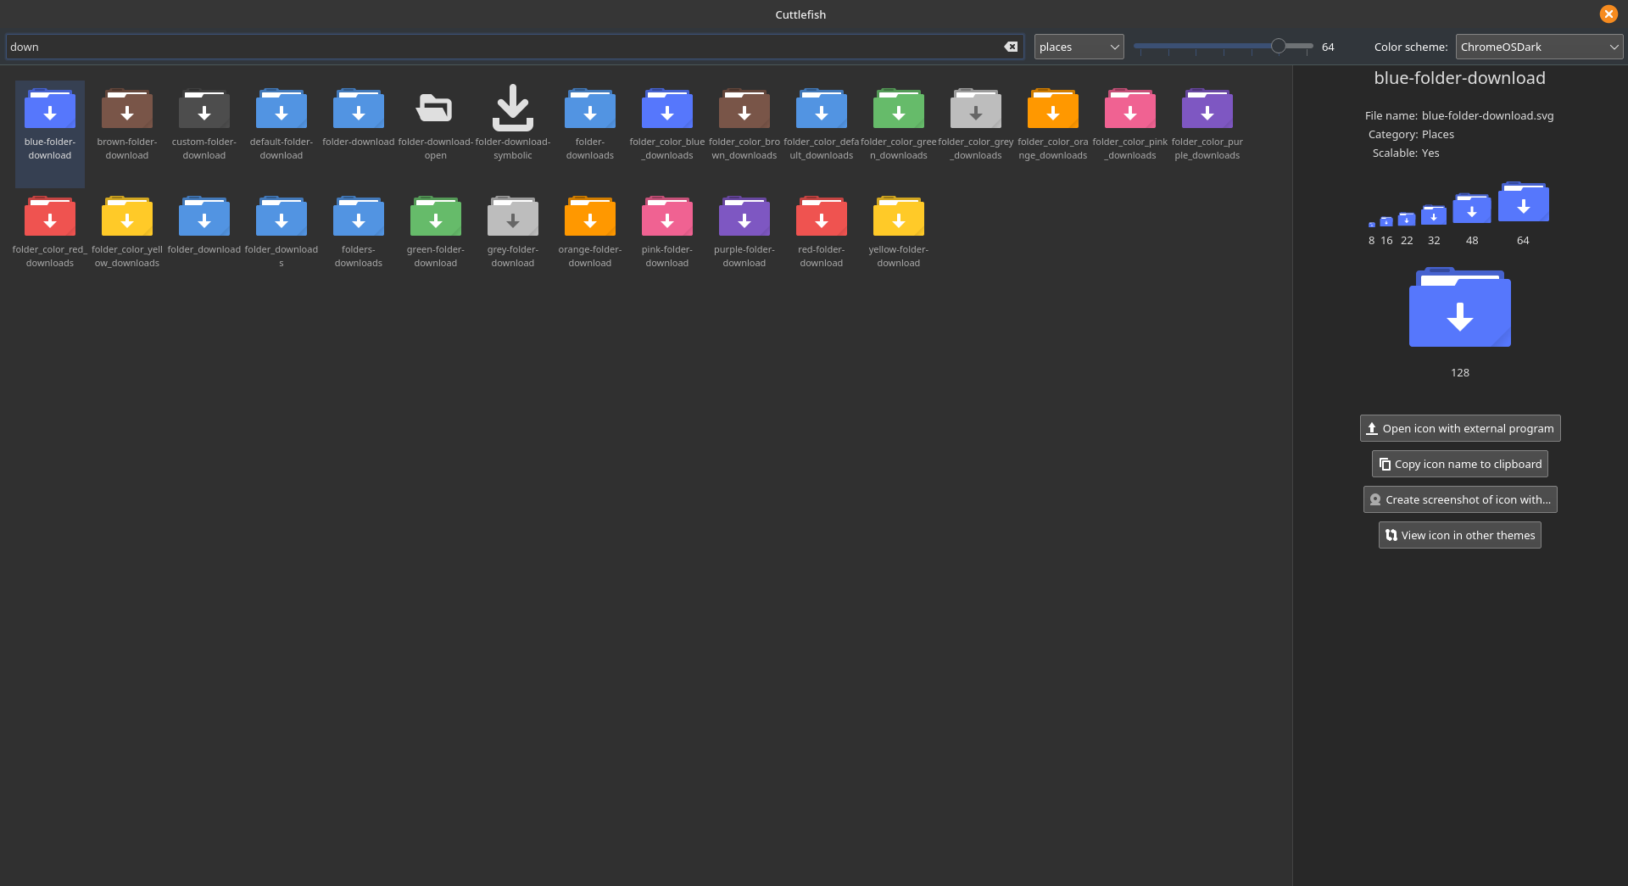
Arc
Arc icons are more of a Faenza breed, being a mid+hard icon pack with Aero (glassy) triats. It is most known for being very solid and classy, and for blending very well with navy blues and dark themes. It is a raster icon pack, but since it doesn’t feature a ton of apps it is relatively small. It does often have issues with the raster icon problem, but usually these can be easily fixed by scaling things by a pixel or two. Personally, I think this one could blend very well with the FIRST colors, but could also be far more monotone and monochromatic than I’m shooting for.

Apps
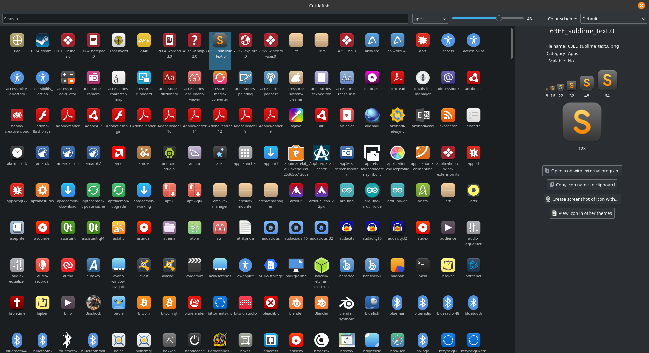

Mimetypes
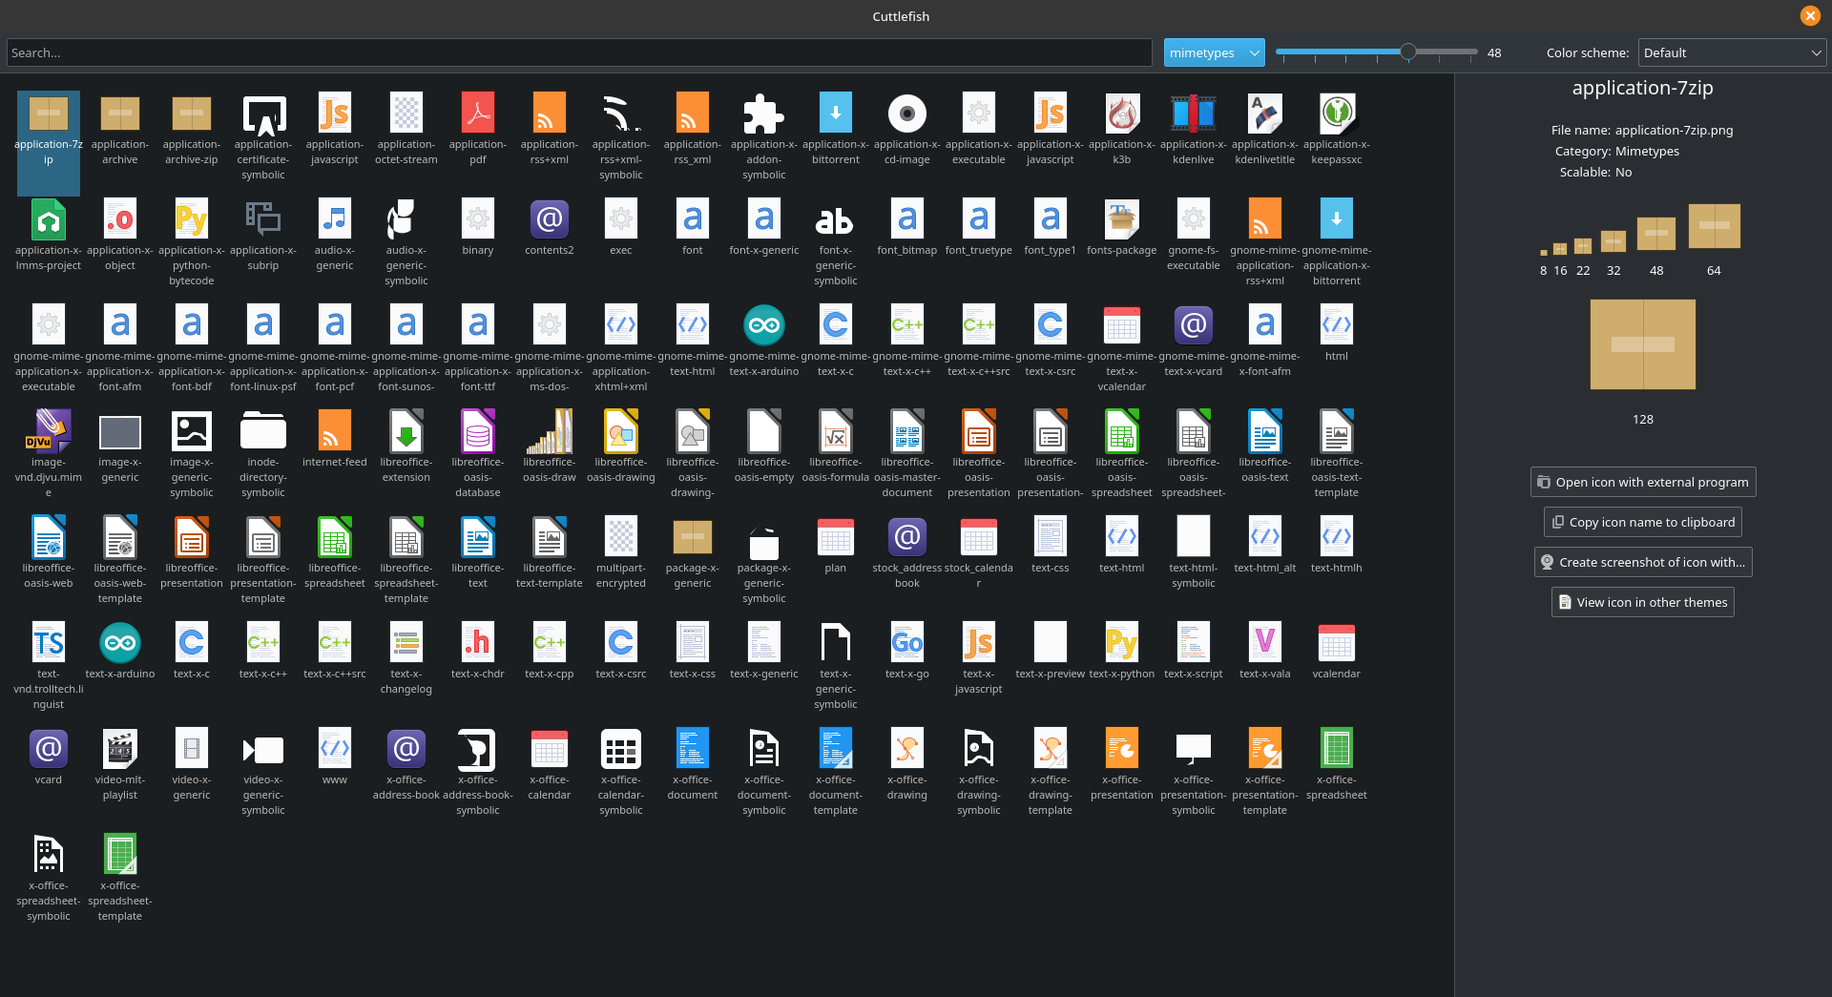

Places
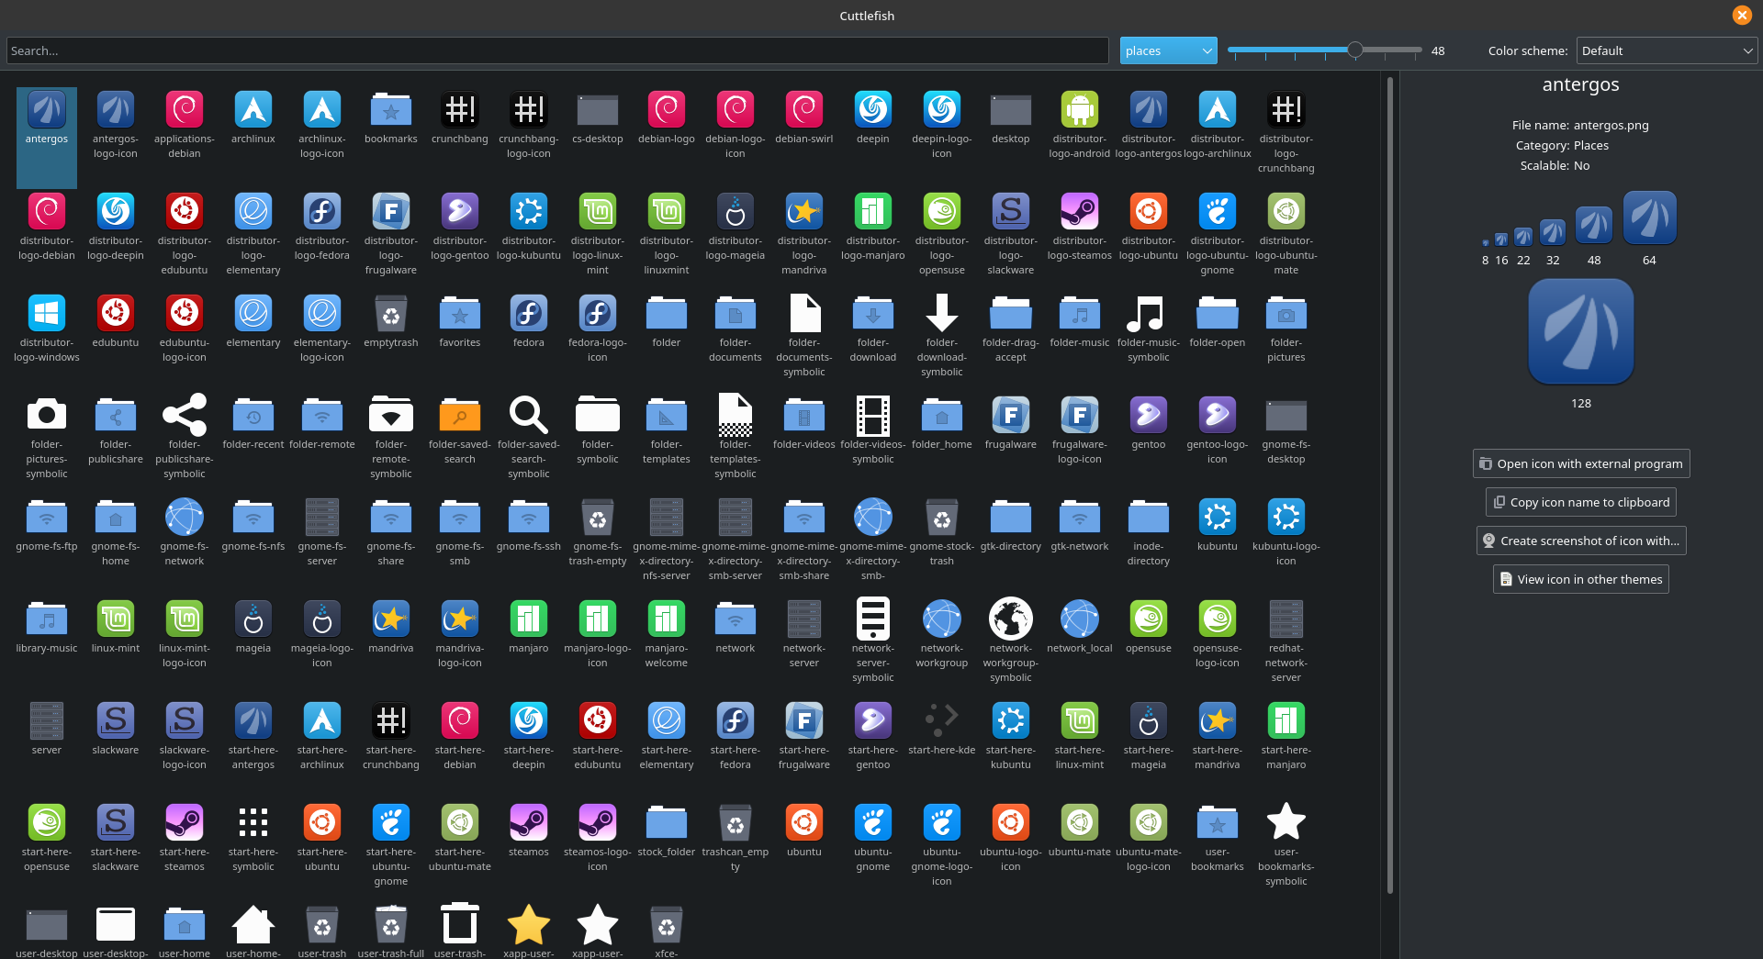

Folder Color Support
Breeze does not feature folder color support.

Fluent
Fluent is more or less the new kid on the block, being a stunning, brand new icon pack that was just recently released. For a brand new icon pack, it covers a good deal of apps and is remarkably stable! The design concept of this icon pack is extremely unique and enticing; it has taken a frosty and yet colorful approach to modern aero. It has hints of a Tela flavor, but the colors, depth and cheer of Papirus. It is a very impressive icon pack and I would absolutely love to make a Distro with it! It is also an entirely vector icon pack.

Apps
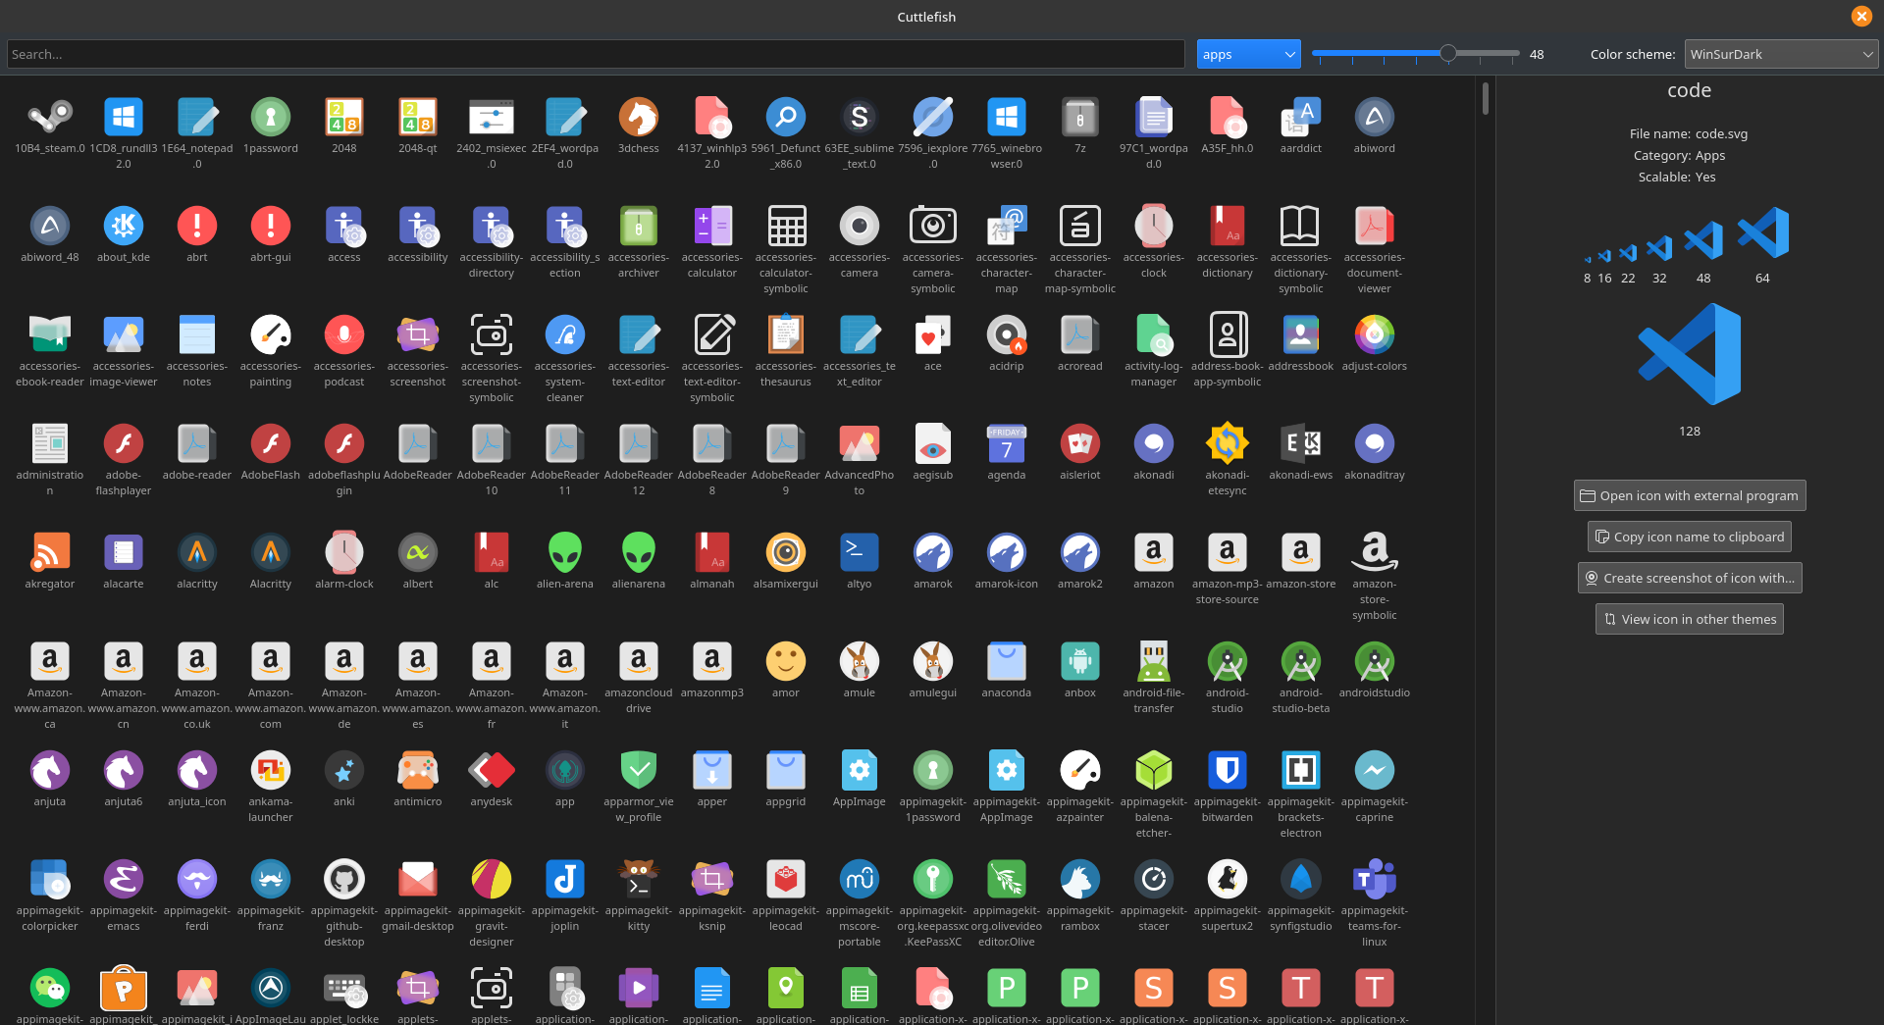

Mime
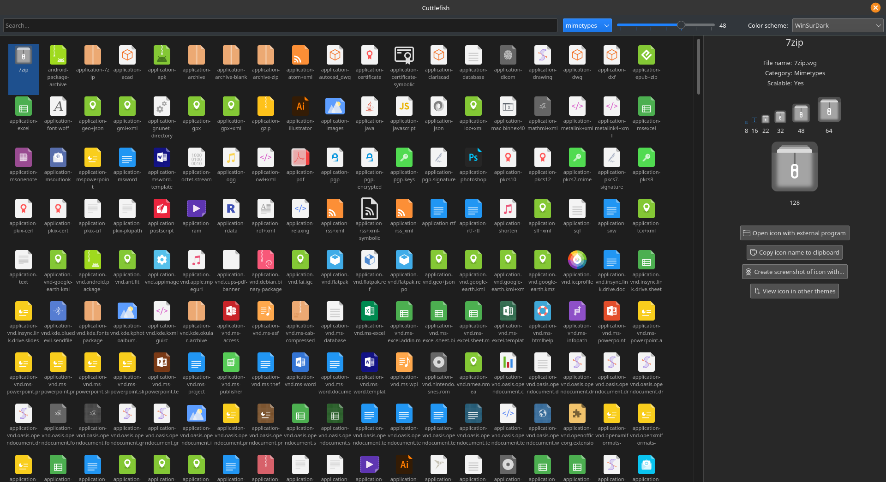

Places
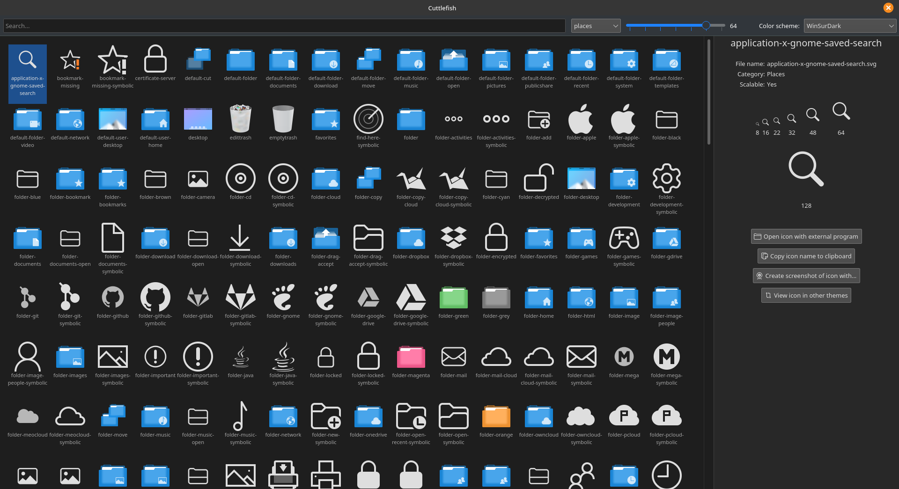

Folder Color Support
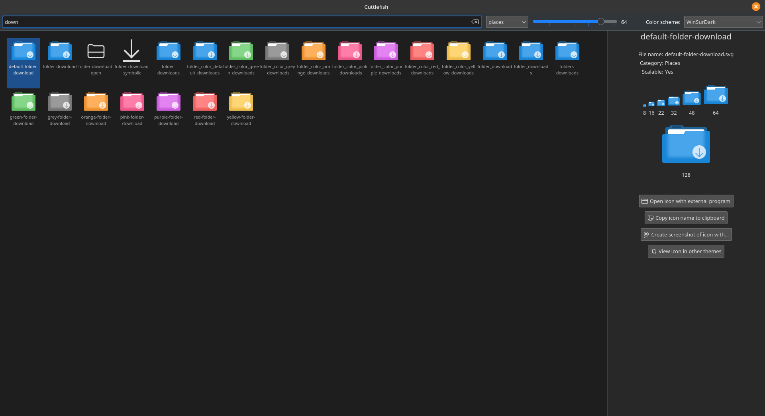

Qogir
Qogir is a material style icon pack that boasts traits of Tela, Papirus, and Arc. It is a very middle of the road icon pack that features a good deal of apps and color variants, but not a ton like some other icon packs. It is as equally hard and soft as it is monochromatic and colorful. It’s a good middle of the road icon pack, and it could fit very nicely with an FRC distro. It too is fully vector.

Apps
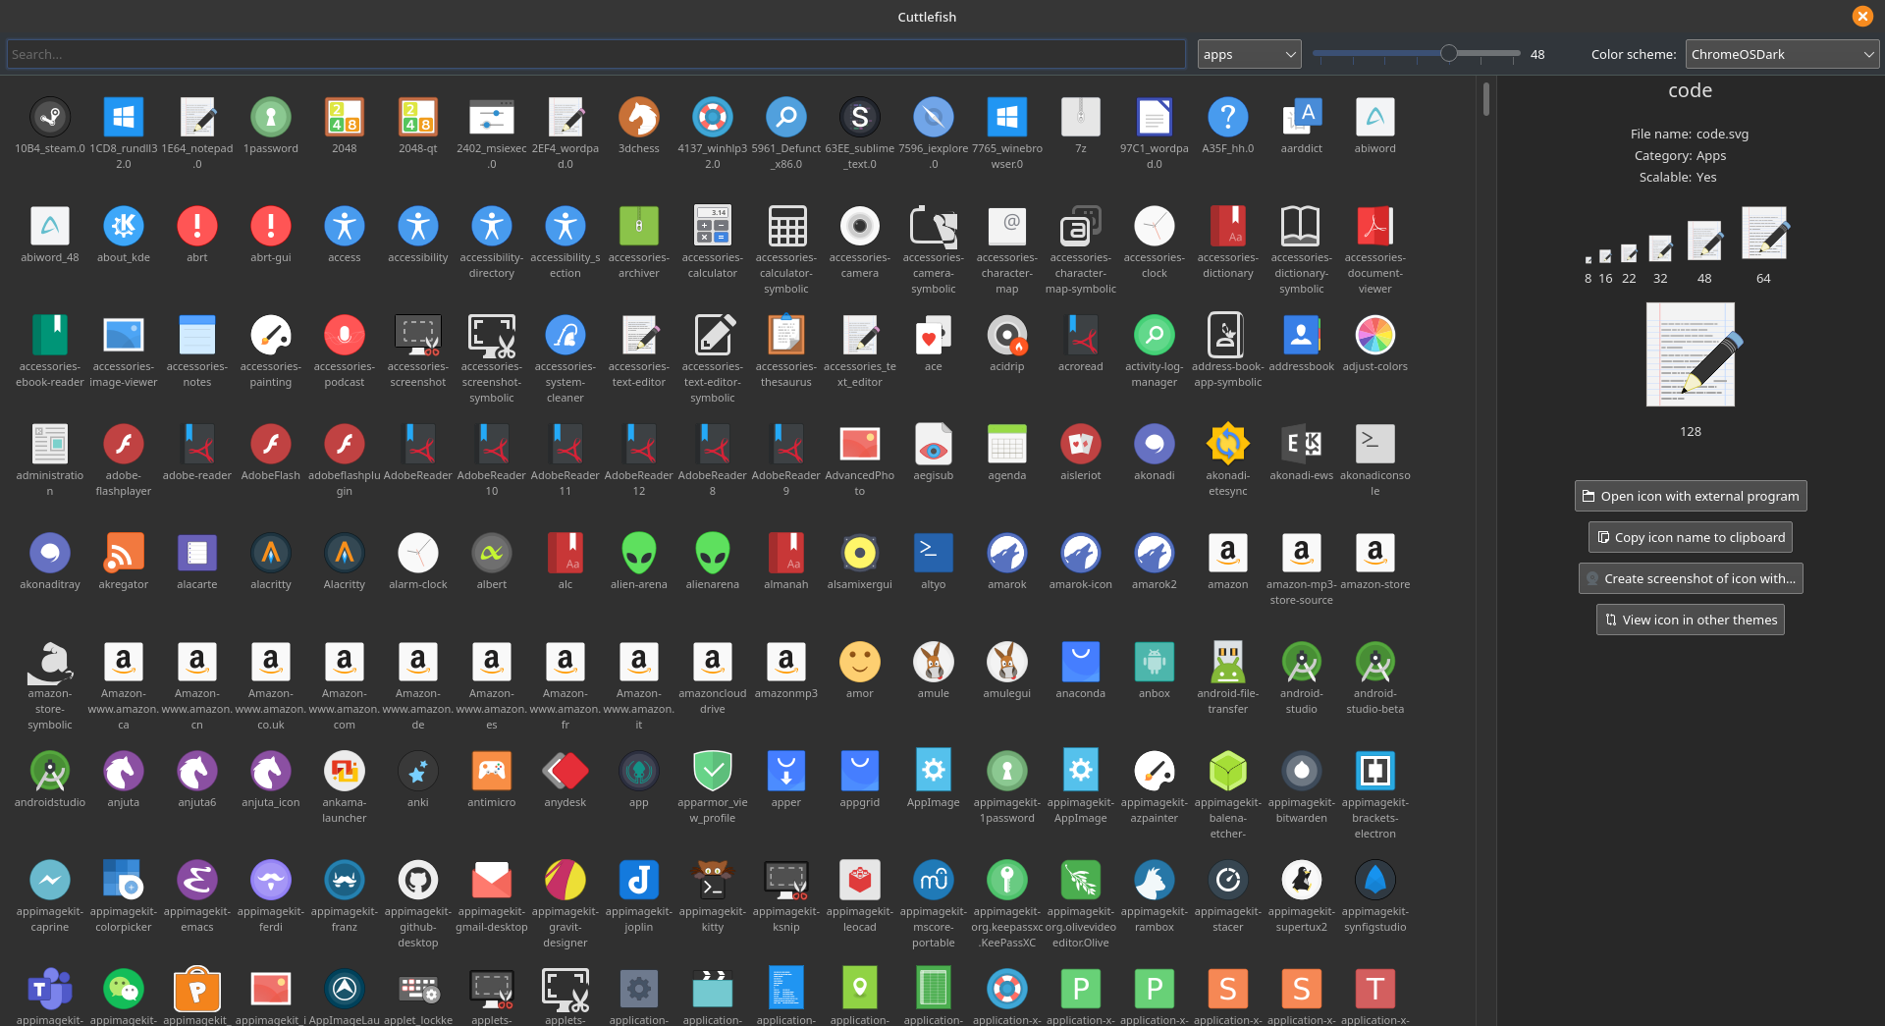

Mimetypes
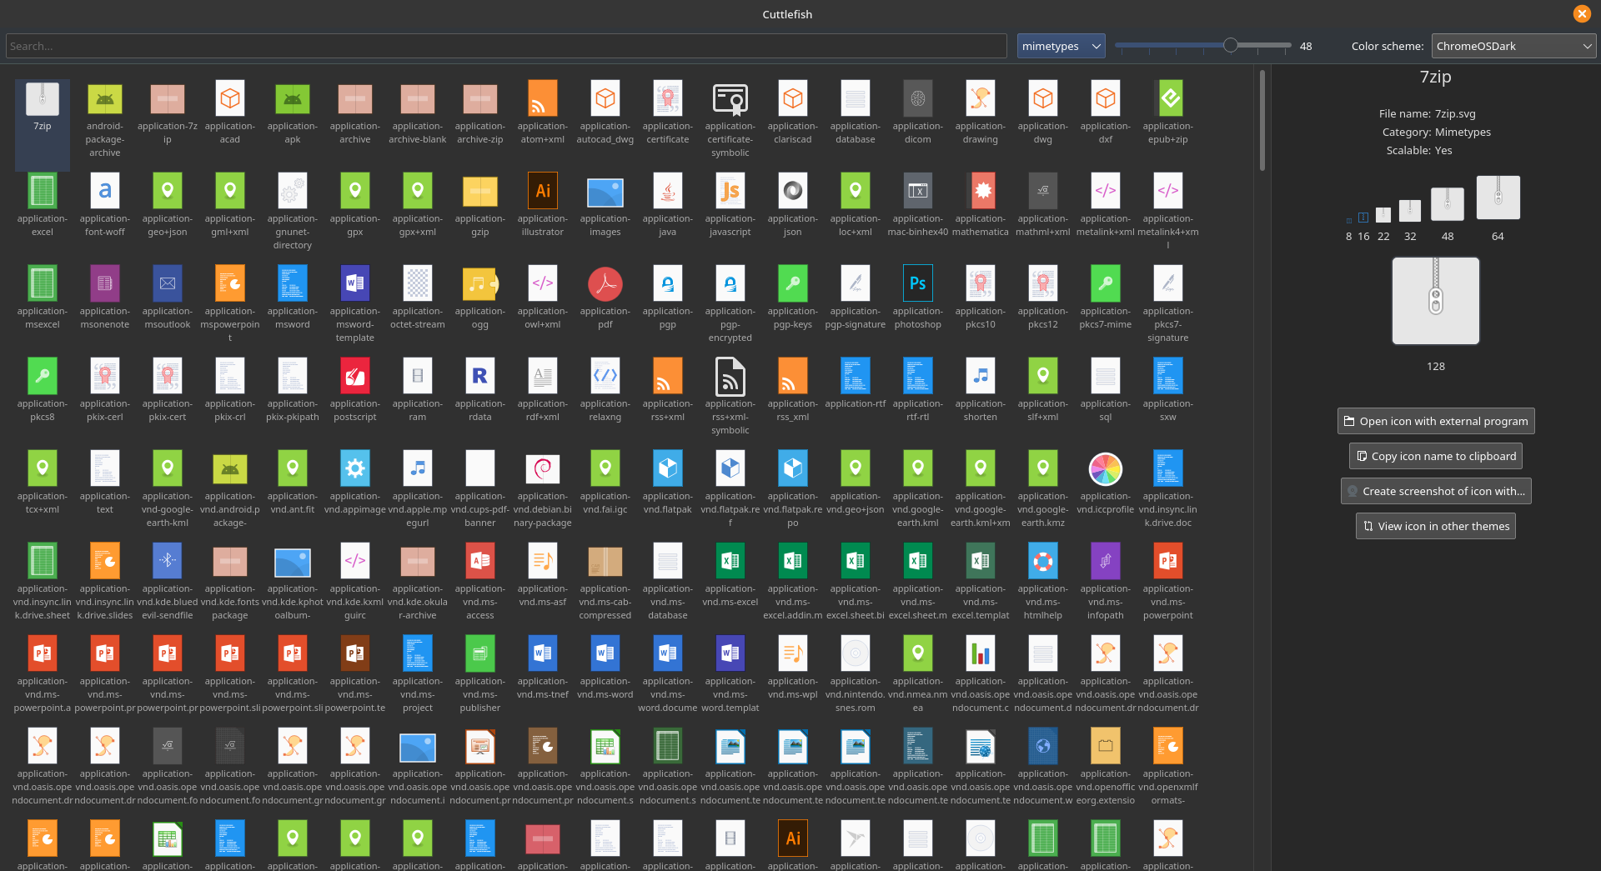

Places
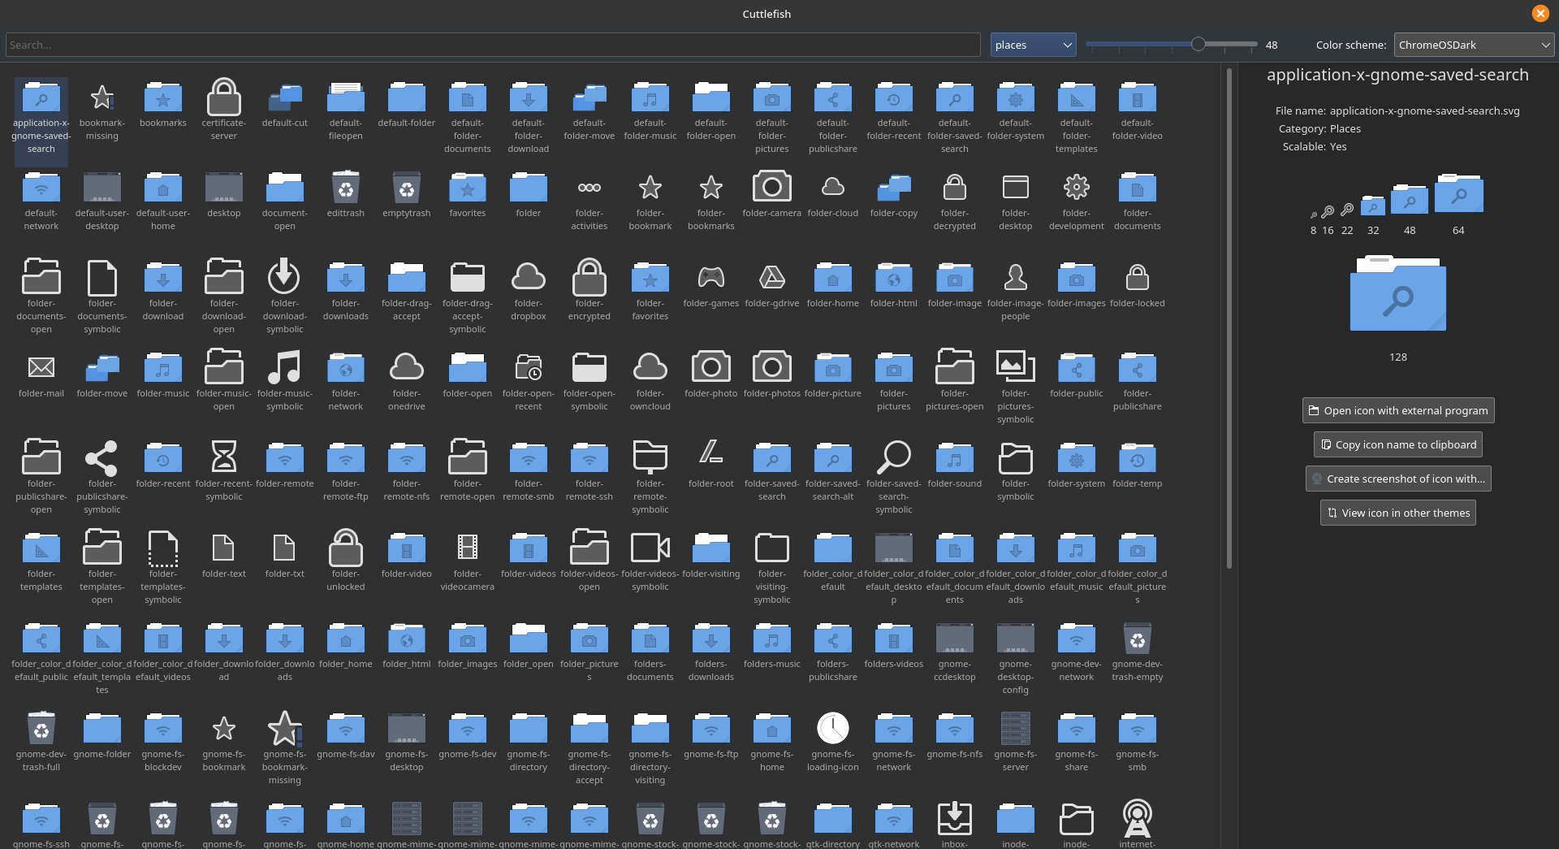

Folder Color Support
Qogir does not feature folder color support.

